|  |  |
| --- | --- |
| *FT Tool Instruction* | |
| Prepared by | Mateusz Fiołek |
| Date | 02.02.2022 |

Table of contents

1 How to use FT Tool 3

# How to use FT Tool

1. Connect USB to UART converter (for example ttl-232) to device.

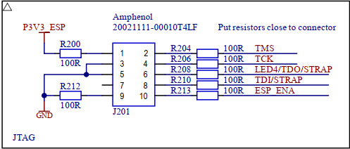

Connect wires to the connector on the device:

* GND to J201 pin 3
* RXT to J201 pin 2 (TMS)
* TXT to J201 pin 4 (TMS)

1. In the provided files edit **FtSrvTool.ini**

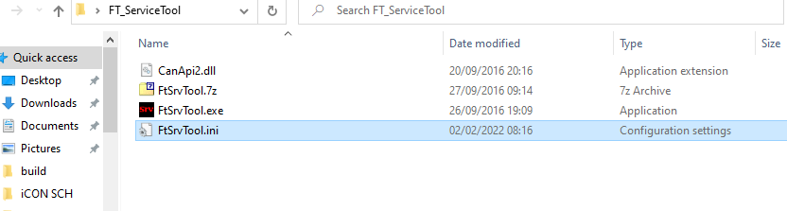

1. In the file on line 13 change the port number to the correct one

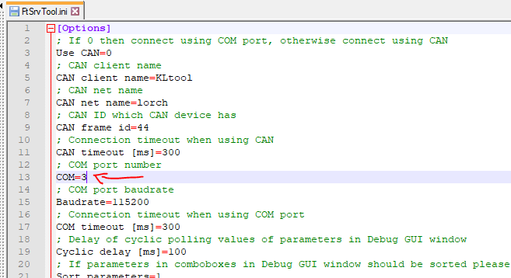

1. Start the program by clicking **FtSrvTool.exe**
2. Such a window should appear.

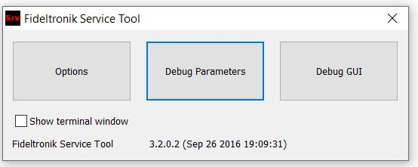

1. Choose “Debug Parameters”

Now a list of all parameters will be displayed.

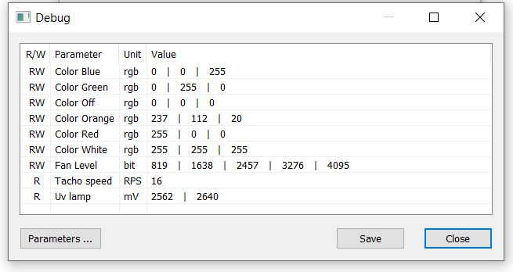

1. By clicking on the parameter marked as “RW” you can modify it.

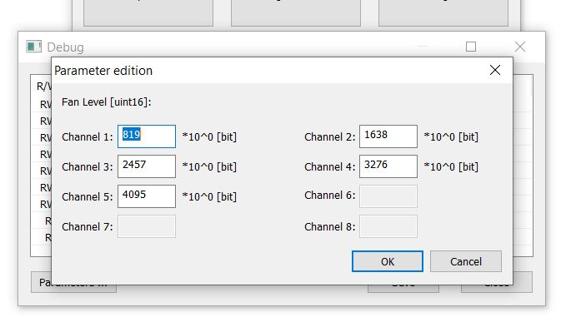

For the changes to take place, you must for fan level change the fan state with the touch button. While for the color of the LEDs then must be a change on the display, e.g. by pressing power button.

**After a power off your changed values will be lost.**